Report

**Online Book Store Management System**

Course Title: System Analysis and Design Lab

Course Code: CSE 306

**Team Members**

Jahidul Islam (21201197)

Sadman Bin Khorshed Amio (21201201)

Taraq Aziz Tanvir (21201203)

**Submitted to,**

Muhtasim Noor Alif

Lecturer

Department of CSE

University of Asia Pacific

**Contents**

|  |  |
| --- | --- |
|  | Problem Definition |
|  | Motivation |
|  | Similar Projects |
|  | Objectives and Output |
|  | System Requirement Specification |
|  | Methodology |
|  | System Design   1. Use Case Diagram 2. Entity Relationship Diagram 3. Data Flow Diagram 4. Class Diagram |
|  | Feasibility Analysis (Economic) |
|  | Project Scheduling (CPM) |
|  | CEP Mapping |
|  | Conclusion |

**Problem Definition**

The Online Bookstore Management System is a comprehensive software solution designed to facilitate the efficient management of an online bookstore. It provides a user-friendly interface for customers to browse, search, and purchase books, while also offering robust administrative tools for managing inventory, orders, and user accounts.

**Motivation**

The motivation behind developing an online book store management system lies in its ability to revolutionize the traditional bookstore model, offering unparalleled convenience to both customers and booksellers. By digitizing inventory management, order processing, and user interaction, the system enhances operational efficiency, reduces overhead costs, and expands market reach beyond geographical constraints. Moreover, it empowers customers with easy access to a vast catalog of books, personalized recommendations, and seamless transactions, thereby enriching their shopping experience. For booksellers, the system provides invaluable insights into sales trends, customer preferences, and inventory performance, enabling data-driven decision-making and fostering business growth. Ultimately, the motivation stems from the desire to innovate within the dynamic landscape of e-commerce, creating a platform that not only meets but exceeds the evolving expectations of modern consumers and businesses alike.

**Similar Projects**

Several similar projects and systems exist in the realm of e-commerce and retail management, each tailored to specific industries or product categories. Here are a few examples:

**Online Retail Management Systems:** These encompass a wide range of products beyond books, including electronics, clothing, home goods, and more. Examples include systems like Shopify, WooCommerce, and Magento, which offer comprehensive solutions for managing online stores, inventory, orders, and customer relationships.

**Library Management Systems:** While different in scope, library management systems share similarities with book store management systems. They focus on cataloging, circulation, and patron management for libraries. Popular examples include Koha and Ex Libris Alma.

**Online Restaurant Ordering System:** This system facilitates online food ordering and delivery for restaurants. Customers can browse menus, place orders, and make payments online, while restaurant staff can manage orders, track deliveries, and monitor inventory levels in real-time.

**Online Ticket Booking System:** This system handles ticket sales and reservations for events, movies, concerts, and other attractions. It allows customers to search for available tickets, select seating options, and purchase tickets securely online, while organizers can manage event details, ticket inventory, and attendee information.

**Online Grocery Store Management System:** This system focuses on managing inventory, orders, and delivery logistics for an online grocery store. It allows customers to browse products, add items to their carts, and schedule deliveries, while also enabling staff to manage inventory levels, track orders, and optimize delivery routes.

**Objectives and Output**

The objective of an online bookstore management system is to efficiently manage all aspects of operating an online bookstore, from inventory management to customer interactions, with the goal of providing a seamless and satisfying shopping experience for customers while optimizing bookstore operations.

The outputs of our project:

**Inventory Management:** The system should provide accurate and up-to-date information about available books, including details such as title, author, genre, price, and quantity in stock.

**Order Processing:** The system should facilitate the smooth processing of orders, from the moment a customer selects a book to the point of payment and fulfillment. This includes generating order confirmations, processing payments securely, and updating inventory levels in real-time.

**User Interaction:** The system should enable customers to interact with the bookstore easily, allowing them to browse the catalog, search for specific books, add items to their shopping carts, and manage their accounts. User can give review on purchased products and also see the review list on their profile.

**Administrative Tools:** The system should provide bookstore staff with administrative tools to manage inventory. This includes features such as adding or removing books from inventory.

System Requirement Specification

**Methodology**

We used waterfall methodology to develop the system. The Waterfall methodology is a sequential software development process that proceeds linearly through defined phases, such as requirements analysis, design, implementation, testing, deployment, and maintenance. While the Waterfall methodology has its advantages and disadvantages.

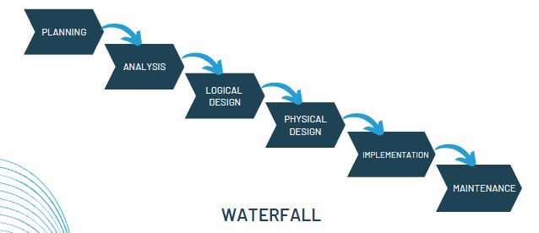

Waterfall methodology have:

**Clear Requirements Definition**: Waterfall's sequential approach allows for thorough documentation and clarification of system requirements upfront, ensuring alignment with stakeholder expectations.

**Structured Approach:** With defined phases like requirements analysis, design, and testing, Waterfall provides a structured framework for development, making it suitable for projects with well-defined objectives like an online bookstore system.

**Documentation Emphasis:** Waterfall encourages comprehensive documentation throughout the development process, which is essential for complex systems like an online bookstore management system to facilitate future maintenance and updates.

**Predictability and Control:** Waterfall offers predictability and control over project timelines and deliverables, providing stakeholders with a clear understanding of progress and facilitating effective resource management.

**Early Issue Detection:** Each phase in Waterfall must be completed before moving to the next, allowing for early detection and mitigation of issues, such as conflicts in requirements, reducing the risk of costly rework later on.

**Stakeholder Engagement:** Waterfall involves frequent interactions with stakeholders, particularly during requirements gathering, ensuring their input is incorporated early, fostering a sense of ownership and buy-in.

While the Waterfall methodology offers these advantages, it's important to consider its limitations, such as less flexibility to accommodate changing requirements and potential difficulties in responding to stakeholder feedback once development has started.

**System Design**

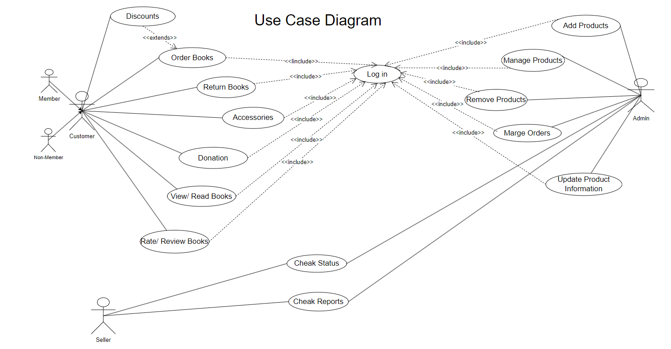

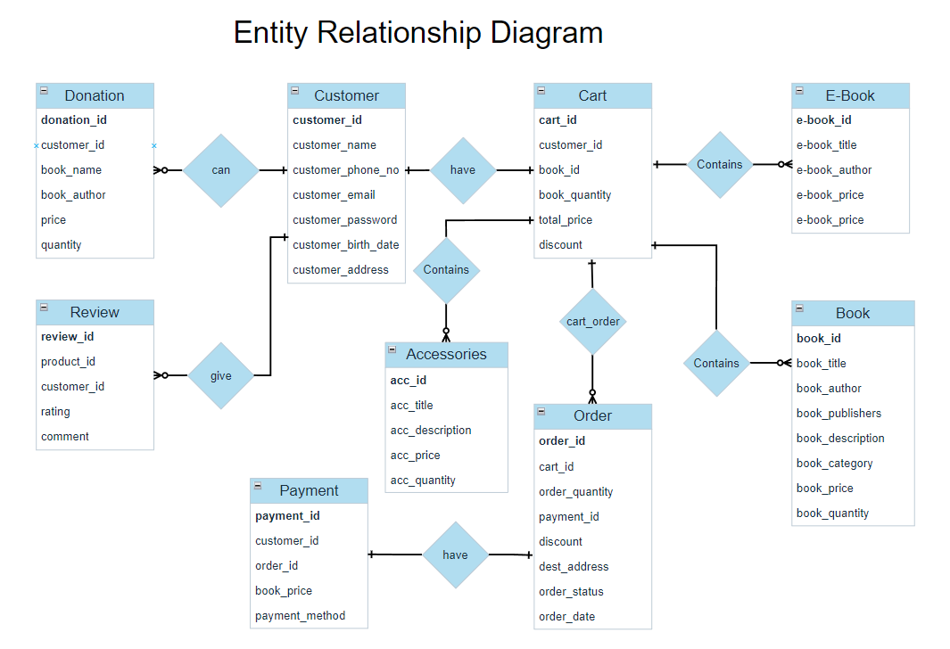

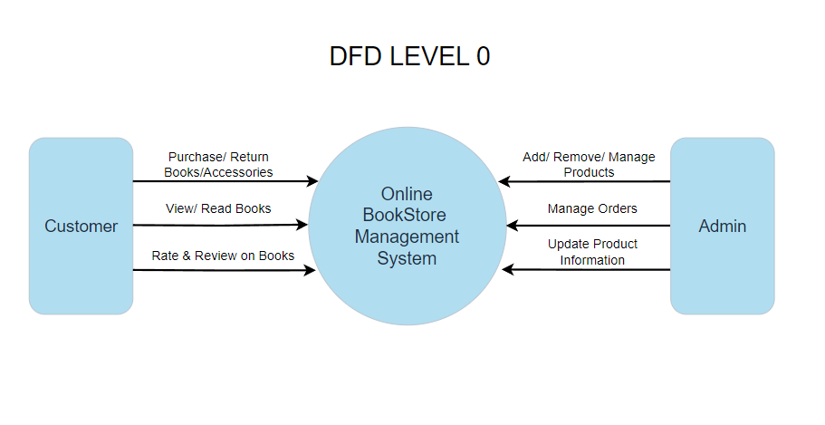

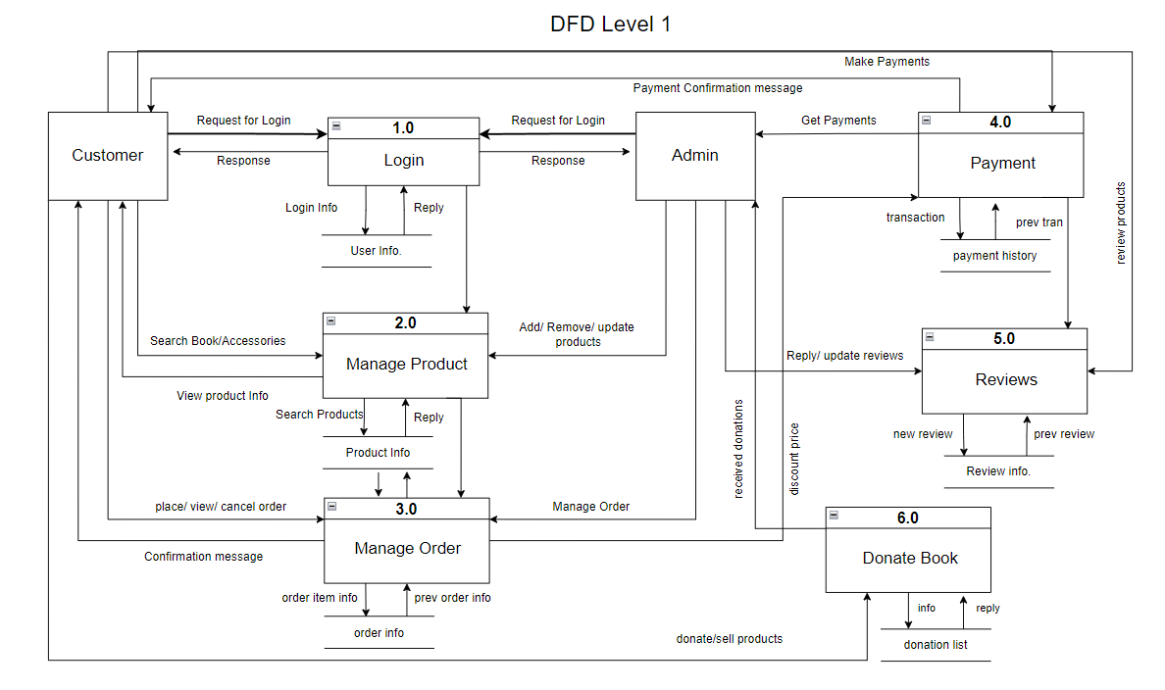

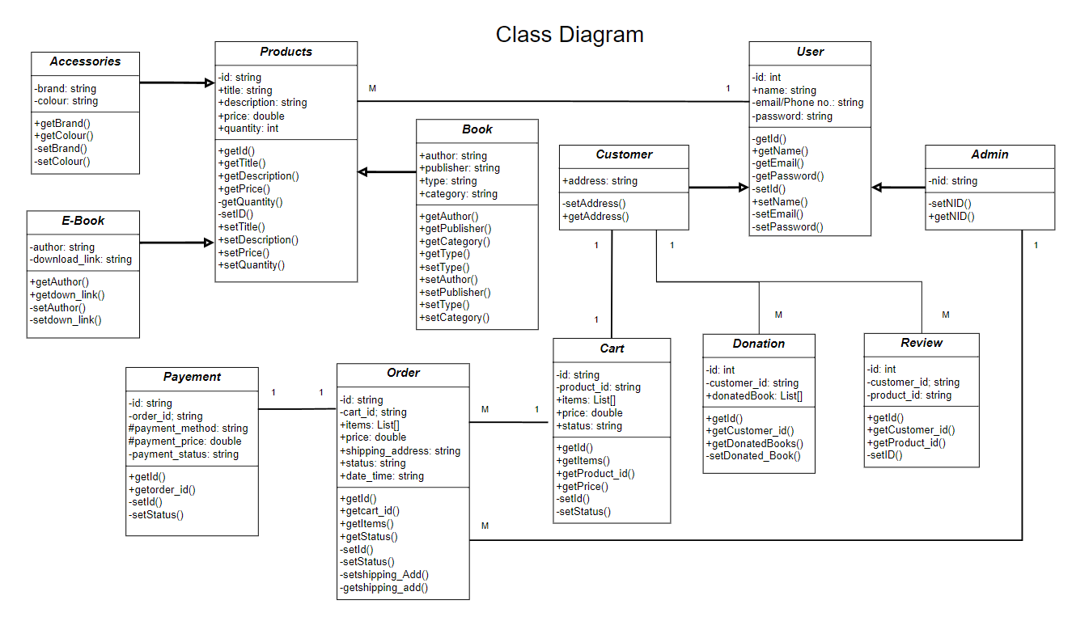

**Feasibility Analysis**

A feasibility analysis for an online bookstore management system across three dimensions: technical feasibility, economic feasibility, and operational feasibility.

Technical Feasibility:

Assess if hardware, software, and integration requirements are met. Ensure compatibility with existing systems and scalability for future needs.

Economic Feasibility:

Conduct a cost-benefit analysis to gauge financial viability. Estimate ROI considering increased revenue and reduced costs. Evaluate budget and resource availability.

Operational Feasibility:

Evaluate user acceptance, aligning with existing processes, and regulatory compliance. Consider usability, training needs, and business process enhancements.

|  |  |  |  |  |
| --- | --- | --- | --- | --- |
| Costs | | | | |
| **Aspects** | **Year 1** | **Year 2** | **Year 3** | **Year 4** |
| Development Costs | 50,000 |  |  |  |
| Hardware Costs | 10,000 | 10,000 |  |  |
| Software Costs | 30,000 |  |  |  |
| Implementation Costs | 20,000 |  |  |  |
| Maintenance Costs |  | 10,000 | 10,000 | 10,000 |
| **Total Costs** | 110,000 | 20,000 | 10,000 | 10,000 |

|  |  |  |  |  |
| --- | --- | --- | --- | --- |
| Benefits | | | | |
| **Aspects** | **Year 1** | **Year 2** | **Year 3** | **Year 4** |
| Increase Sales | 50,000 | 100,000 | 150,000 | 200,000 |
| Cost Savings |  | 20,000 | 30,000 | 40,000 |
| Customer Satisfaction |  |  | 5,000 | 8,000 |
| Market Expansion |  |  | 15,000 | 25,000 |
| Improved Efficiency |  |  | 10,000 | 20,000 |
| **Total Benefits** | 50,000 | 120,000 | 210,000 | 293,000 |
| **Net Benefit**  **(Benefits-Costs)** | -60,000 | 100,000 | 210,000 | 283,000 |

Return on Investment (ROI) = ((Total Benefit – Total Cost) / Total Cost) * 100

= ((673000 – 150,000) / 150,000) * 100 = 348.7%

**Project Scheduling (CPM)**

|  |  |  |  |  |  |  |  |  |
| --- | --- | --- | --- | --- | --- | --- | --- | --- |
| **Task ID** | **Task Description** | **Predecessor** | **Weeks** | **Earliest Start** | **Earliest Finish** | **Late Start** | **Late Finish** | **Slack Time** |
| A | Project Initiation | ----- | 2 | 0 | 2 | 0 | 2 | 0 |
| B | Requirement Analysis | A | 2 | 2 | 4 | 2 | 4 | 0 |
| C | System Design | A, B | 4 | 4 | 8 | 4 | 8 | 0 |
| D | Development | B, C | 6 | 8 | 14 | 8 | 14 | 0 |
| E | Testing | D | 3 | 14 | 17 | 14 | 17 | 0 |
| F | Deployment | E | 2 | 17 | 19 | 17 | 19 | 0 |
| G | Training | F | 1 | 19 | 20 | 19 | 20 | 0 |

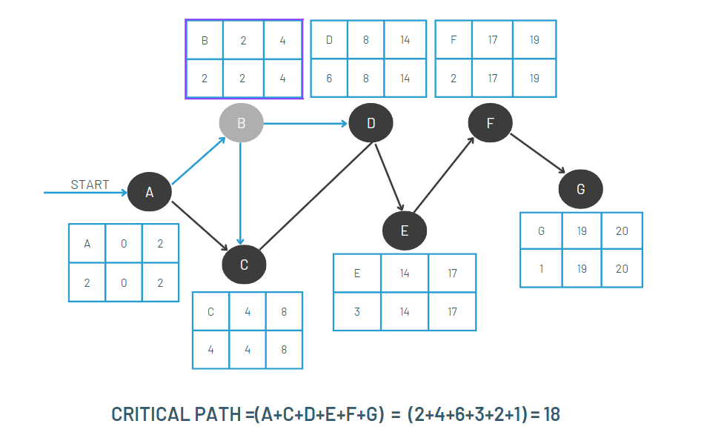

**Conclusion**

The development and implementation of an online bookstore management system offer numerous benefits for both bookstore owners and customers. By streamlining inventory management, order processing, and customer interactions, the system enhances operational efficiency, improves customer satisfaction, and drives business growth in the competitive online retail landscape. Through a thorough feasibility analysis, it's evident that the technical, economic, and operational aspects of the project are viable and promising. With the potential to increase sales, reduce costs, and gain a competitive advantage, investing in an online bookstore management system represents a strategic opportunity for bookstore owners to modernize their operations and adapt to the evolving needs of the digital marketplace.